1. CCNA Security

Chapter 10 – Configure AnyConnect Remote Access SSL VPN Using ASDM (Instructor Version)

(ASA-5506 / Equiv)

**Instructor Note**: Red font color or gray highlights indicate text that appears in the instructor copy only.

|  |  |
| --- | --- |
|  | **This lab has been updated for use on NETLAB+.**  [**www.netdevgroup.com**](https://www.netdevgroup.com/) |

1. Topology

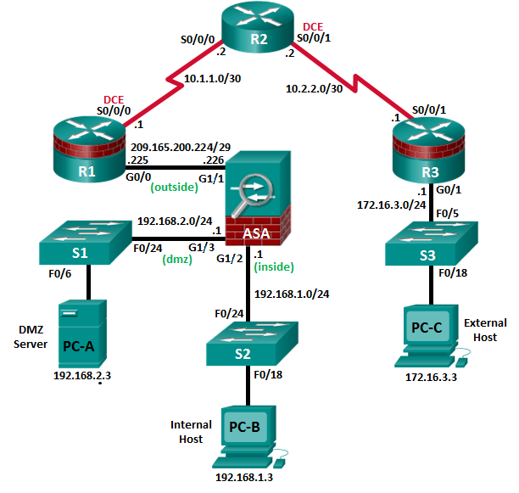

**Note**: ISR G1 devices use FastEthernet interfaces instead of GigabitEthernet interfaces.

1. IP Addressing Table

|  |  |  |  |  |  |
| --- | --- | --- | --- | --- | --- |
| Device | Interface | IP Address | Subnet Mask | Default Gateway | Switch Port |
| R1 | G0/0 | 209.165.200.225 | 255.255.255.248 | N/A | ASA G1/1 |
| S0/0/0 (DCE) | 10.1.1.1 | 255.255.255.252 | N/A | N/A |
| R2 | S0/0/0 | 10.1.1.2 | 255.255.255.252 | N/A | N/A |
| S0/0/1 (DCE) | 10.2.2.2 | 255.255.255.252 | N/A | N/A |
| R3 | G0/1 | 172.16.3.1 | 255.255.255.0 | N/A | S3 F0/5 |
| S0/0/1 | 10.2.2.1 | 255.255.255.252 | N/A | N/A |
| ASA | Gi1/2 | 192.168.1.1 | 255.255.255.0 | NA | S2 F0/24 |
| Gi1/1 | 209.165.200.226 | 255.255.255.248 | NA | R1 G0/0 |
| Gi1/3 | 192.168.2.1 | 255.255.255.0 | NA | S1 F0/24 |
| PC-A | NIC | 192.168.2.3 | 255.255.255.0 | 192.168.2.1 | S1 F0/6 |
| PC-B | NIC | 192.168.1.3 | 255.255.255.0 | 192.168.1.1 | S2 F0/18 |
| PC-C | NIC | 172.16.3.3 | 255.255.255.0 | 172.16.3.1 | S3 F0/18 |

1. Objectives

Part 1: Basic Router/Switch/PC Configuration

* Configure basic settings for routers.
* Configure PC host IP settings.
* Verify connectivity.
* Save the basic running configuration for each router and switch.

Part 2: Access the ASA Console and ASDM

* Access the ASA console.
* Clear the previous ASA configuration settings.
* Bypass Setup mode.
* Configure the ASA by using the CLI script.
* Access ASDM.

Part 3: Configuring AnyConnect Client SSL VPN Remote Access Using ASDM

* Start the VPN wizard.
* Specify the VPN encryption protocol.
* Specify the client image to upload to AnyConnect users.
* Configure AAA local authentication.
* Configure the client address assignment.
* Configure the network name resolution.
* Exempt address translation for VPN traffic.
* Review the AnyConnect client deployment details.
* Review the Summary screen and apply the configuration to the ASA.

Part 4: Connecting to an AnyConnect SSL VPN

* Verify the AnyConnect client profile.
* Log in from the remote host.
* Perform platform detection (if required).
* Perform an automatic installation of the AnyConnect VPN Client (if required).
* Manually install the AnyConnect VPN Client (if required).
* Confirm VPN connectivity.

1. Background/Scenario

In addition to stateful firewall and other security features, the ASA can provide both site-to-site and remote access VPN functionality. The ASA provides two main deployment modes that are found in Cisco SSL remote access VPN solutions:

* **Clientless SSL VPN -** A clientless, browser-based VPN that lets users establish a secure, remote-access VPN tunnel to the ASA and use a web browser and built-in SSL to protect VPN traffic. After authentication, users are presented with a portal page and can access specific, predefined internal resources from the portal.
* **Client-Based SSL VPN -** A client-based VPN that provides full-tunnel SSL VPN connection, but requires a VPN client application to be installed on the remote host. After authentication, users can access any internal resource as if they were physically on the local network. The ASA supports both SSL and IPsec client-based VPNs.

In Part 1 of this lab, you will configure the topology and non-ASA devices. In Part 2, you will prepare the ASA for ASDM access. In Part 3, you will use the ASDM VPNwizard to configure an AnyConnect client-based SSL remote access VPN. In Part 4 you will establish a connection and verify connectivity.

Your company has two locations connected to an ISP. R1 represents a CPE device managed by the ISP. R2 represents an intermediate Internet router. R3 connects users at the remote branch office to the ISP. The ASA is an edge security device that connects the internal corporate network and DMZ to the ISP while providing NAT services to inside hosts.

Management has asked you to provide VPN access to teleworkers using the ASA as a VPN concentrator. They want you to test the client-based model using SSL and the Cisco AnyConnect client.

**Note**: The router commands and output in this lab are from a Cisco 1941 router with Cisco IOS Release 15.4(3)M2 (with a Security Technology Package license). Other routers and Cisco IOS versions can be used. See the Router Interface Summary Table at the end of the lab to determine which interface identifiers to use based on the equipment in the lab. Depending on the router model and Cisco IOS version, the commands available and the output produced might vary from what is shown in this lab.

The ASA used with this lab is a Cisco model 5506 with an 8-port integrated router, running OS version 9.8(1), Adaptive Security Device Manager (ASDM) version 7.8(1), and comes with a Base license.

**Instructor Note**: AnyConnect Secure Mobility Client release 4.1 or later is recommended. Instructions for installing AnyConnect Client packages to ASA flash are provided in the Chapter 0.0.0.0 lab.

**Instructor Note**: Instructions for erasing switches and routers are provided in Chapter 0.0.0.0. Instructions for erasing the ASA, accessing the console, and accessing ASDM are provided in this lab.

1. Basic Router/Switch/PC Configuration

In Part 1, you will configure basic settings on the routers such as interface IP addresses and static routing.

**Note**: Do not configure any ASA settings at this time.

* + 1. Configure R1 using the CLI script.

In this step, you will use the following CLI script to configure basic settings on R1. Copy and paste the basic configuration script commands listed below. Observe the messages as the commands are applied to ensure that there are no warnings or errors.

**Note**: Depending on the router model, interfaces might be numbered differently than those listed. You might need to alter the designations accordingly.

**Note**: Passwords in this task are set to a minimum of 10 characters and are relatively simple for the purposes of performing the lab. More complex passwords are recommended in a production network.

enable

config t

hostname R1

security passwords min-length 10

enable algorithm-type scrypt secret cisco12345

username admin01 algorithm-type scrypt secret admin01pass

ip domain name ccnasecurity.com

line con 0

login local

exec-timeout 5 0

logging synchronous

exit

line vty 0 4

login local

transport input ssh

exec-timeout 5 0

logging synchronous

exit

interface gigabitethernet 0/0

ip address 209.165.200.225 255.255.255.248

no shut

exit

int serial 0/0/0

ip address 10.1.1.1 255.255.255.252

clock rate 2000000

no shut

exit

ip route 0.0.0.0 0.0.0.0 Serial0/0/0

crypto key generate rsa general-keys modulus 1024

* + 1. Configure R2 using the CLI script.

In this step, you will use the following CLI script to configure basic settings on R2. Copy and paste the basic configuration script commands listed below. Observe the messages as the commands are applied to ensure that there are no warnings or errors.

enable

config t

hostname R2

security passwords min-length 10

enable algorithm-type scrypt secret cisco12345

username admin01 algorithm-type scrypt secret admin01pass

ip domain name ccnasecurity.com

line con 0

login local

exec-timeout 5 0

logging synchronous

exit

line vty 0 4

login local

transport input ssh

exec-timeout 5 0

logging synchronous

exit

interface serial 0/0/0

ip address 10.1.1.2 255.255.255.252

no shut

exit

interface serial 0/0/1

ip address 10.2.2.2 255.255.255.252

clock rate 2000000

no shut

exit

ip route 209.165.200.224 255.255.255.248 Serial0/0/0

ip route 172.16.3.0 255.255.255.0 Serial0/0/1

crypto key generate rsa general-keys modulus 1024

* + 1. Configure R3 using the CLI script.

In this step, you will use the following CLI script to configure basic settings on R3. Copy and paste the basic configuration script commands listed below. Observe the messages as the commands are applied to ensure that there are no warnings or errors.

enable

config t

hostname R3

security passwords min-length 10

enable algorithm-type scrypt secret cisco12345

username admin01 algorithm-type scrypt secret admin01pass

ip domain name ccnasecurity.com

line con 0

login local

exec-timeout 5 0

logging synchronous

exit

line vty 0 4

login local

transport input ssh

exec-timeout 5 0

logging synchronous

exit

interface gigabitethernet 0/1

ip address 172.16.3.1 255.255.255.0

no shut

exit

int serial 0/0/1

ip address 10.2.2.1 255.255.255.252

no shut

exit

ip route 0.0.0.0 0.0.0.0 Serial0/0/1

crypto key generate rsa general-keys modulus 1024

* + 1. **Configure PC host IP settings.**

Configure a static IP address, subnet mask, and default gateway for PC-A, PC-B, and PC-C as shown in the IP Addressing table.

* + 1. **Verify connectivity.**

The ASA is the focal point for the network zones, and it has not yet been configured. Therefore, there will be no connectivity between devices that are connected to it. However, PC-C should be able to ping the R1 interface G0/0. From PC-C, ping the R1 G0/0 IP address (**209.165.200.225**). If these pings are unsuccessful, troubleshoot the basic device configurations before continuing.

**Note**: If you can ping from PC-C to R1 G0/0 and S0/0/0, you have demonstrated that static routing is configured and functioning correctly.

* + 1. **Save the basic running configuration for each router and switch.**

1. Accessing the ASA Console and ASDM
   * 1. Clear the previous ASA configuration settings.
        1. Use the **write erase** command to remove the **startup-config** file from flash memory.

**Note**: The **erase startup-config** IOS command is not supported on the ASA.

* + - 1. Use the **reload** command to restart the ASA. This causes the ASA to display in CLI Setup mode. If you see the **System config has been modified. Save? [Y]es/[N]o:** message, type **N**, and press **Enter**.
    1. Bypass Setup mode.

When the ASA completes the reload process, it should detect that the startup configuration file is missing and go into Setup mode. If it does not go into Setup mode, repeat Step 1.

* + - 1. When prompted to preconfigure the firewall through interactive prompts (Setup mode), respond with **No**.
      2. Enter privileged EXEC mode with the **enable** command. The password should be blank (no password).
    1. Configure the ASA by using the CLI script.

In this step, you will use a CLI script to configure basic settings, the firewall, and the DMZ.

* + - 1. Use the **show run** command to confirm that there is no previous configuration in the ASA other than the defaults that the ASA automatically inserts.
      2. Enter global configuration mode. When prompted to enable anonymous call-home reporting, respond **no**.
      3. Copy and paste the Pre-VPN Configuration Script commands listed below at the ASA global configuration mode prompt to start configuring the SSL VPNs.

Observe the messages as the commands are applied to ensure that there are no warnings or errors. If prompted to replace the RSA key pair, respond **yes**.

hostname CCNAS-ASA

domain-name ccnasecurity.com

enable password cisco12345

!

interface Gigabit1/1

nameif outside

security-level 0

ip address 209.165.200.226 255.255.255.248

no shut

!

interface Gigabit1/2

nameif inside

security-level 100

ip address 192.168.1.1 255.255.255.0

no shut

!

interface Gigabit1/3

nameif dmz

security-level 70

ip address 192.168.2.1 255.255.255.0

no shut

!

object network inside-net

subnet 192.168.1.0 255.255.255.0

!

object network dmz-server

host 192.168.2.3

!

access-list OUTSIDE-DMZ extended permit ip any host 192.168.2.3

!

object network inside-net

nat (inside,outside) dynamic interface

!

object network dmz-server

nat (dmz,outside) static 209.165.200.227

!

access-group OUTSIDE-DMZ in interface outside

!

route outside 0.0.0.0 0.0.0.0 209.165.200.225 1

!

username admin01 password admin01pass

!

aaa authentication telnet console LOCAL

aaa authentication ssh console LOCAL

aaa authentication http console LOCAL

!

http server enable

http 192.168.1.0 255.255.255.0 inside

ssh 192.168.1.0 255.255.255.0 inside

telnet 192.168.1.0 255.255.255.0 inside

telnet timeout 10

ssh timeout 10

!

class-map inspection_default

match default-inspection-traffic

policy-map global_policy

class inspection_default

inspect icmp

!

crypto key generate rsa modulus 1024

* + - 1. At the privileged EXEC mode prompt, issue the **write mem** (or **copy run start**) command to save the running configuration to the startup configuration and the RSA keys to non-volatile memory.
    1. Access ASDM.
       1. Open a browser on PC-B and test the HTTPS access to the ASA by entering **https://192.168.1.1**. After entering the https://192.168.1.1 URL, you should see a security warning about the website security certificate. Click **Continue to this website**. Click **Yes** for any other security warnings.

**Note**: Specify the HTTPS protocol in the URL.

* + - 1. At the ASDM welcome page, click **Run ASDM**. The ASDM-IDM Launcher will display. Log in as user **admin01** with the password **admin01pass**.

**Note:** You will need to accept all security messages and/or add the ASA IP address to the allowed list of IP addresses in Java.

If the “*Run ASDM*” button via Java is not accessible, access your ASA via **https://<ip_address>/admin/public/asdm.jnlp** to download the JNLP file and then open the file to continue using ASDM.

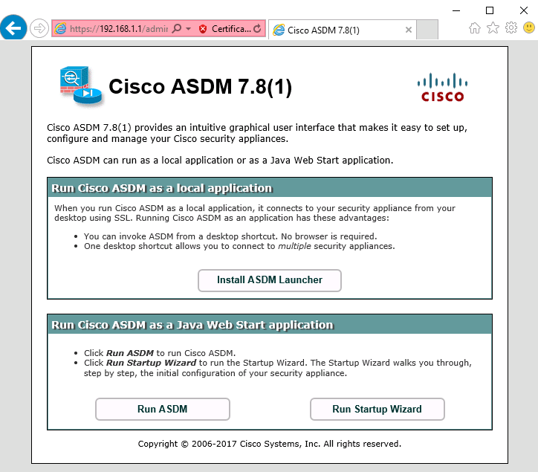

1. Configuring AnyConnect SSL VPN Remote Access Using ASDM
   * 1. Start the VPN wizard.
        1. On the ASDM main menu, click **Wizards** > **VPN Wizards** > **AnyConnect VPN Wizard**.
        2. Review the on-screen text and topology diagram. Click **Next** to continue.

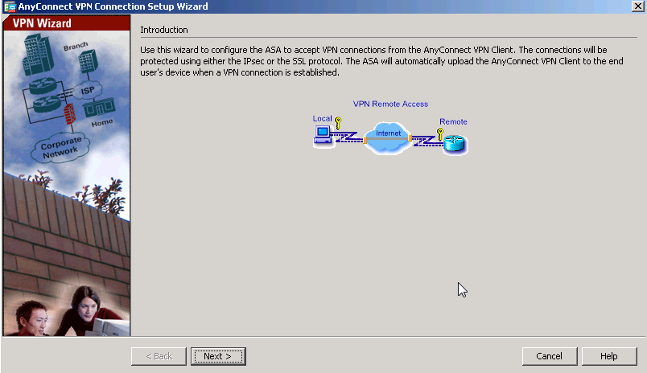

* + 1. Configure the SSL VPN interface connection profile.

On the Connection Profile Identificationscreen, enter **AnyConnect-SSL-VPN** as the Connection Profile Name and specify the **outside** interface as the VPN Access Interface. Click **Next** to continue.

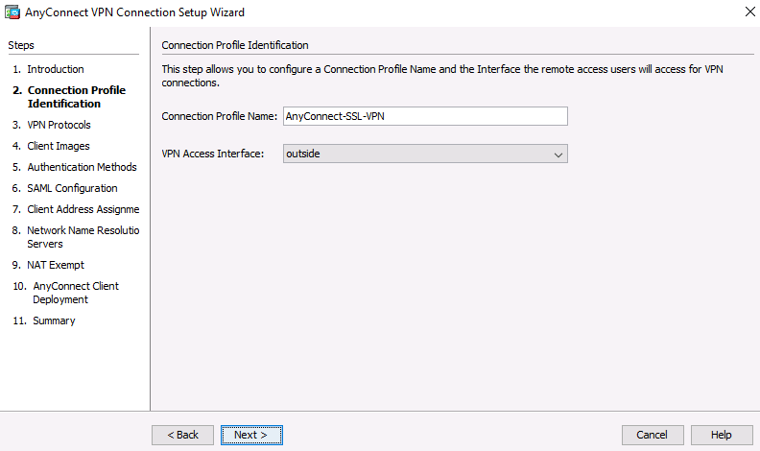

* + 1. Specify the VPN encryption protocol.

On the VPN Protocolsscreen, **uncheck** the **IPsec** check box and leave the **SSL** check box checked. Do not specify a device certificate. Click **Next** to continue.

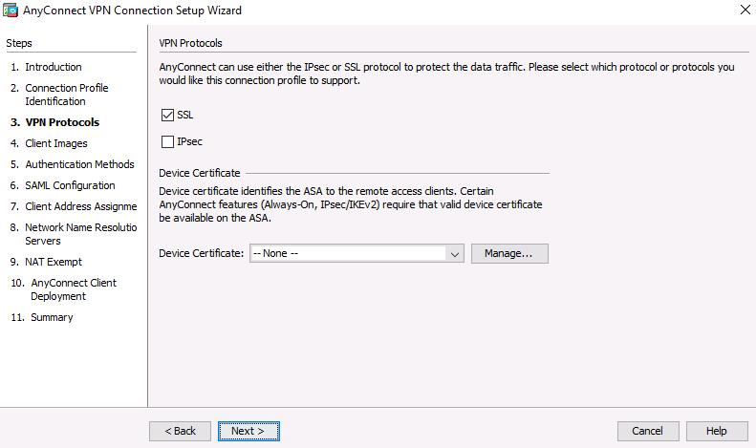

* + 1. Specify the client image to upload to AnyConnect users.
       1. On the Client Imagesscreen, click **Add** to specify the AnyConnect client image filename.

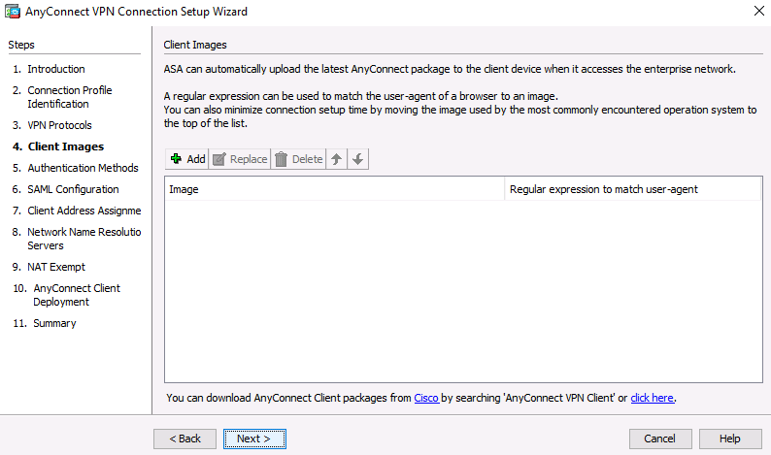

* + - 1. In the Add AnyConnect Client Image window, click **Browse Flash**.

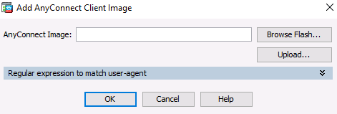

* + - 1. In the Browse Flash window, select the AnyConnect package file for Windows (**anyconnect-win-4.XXXXXXXX.pkg**, see the example). Click **OK** to return to the AnyConnect Client Image window.

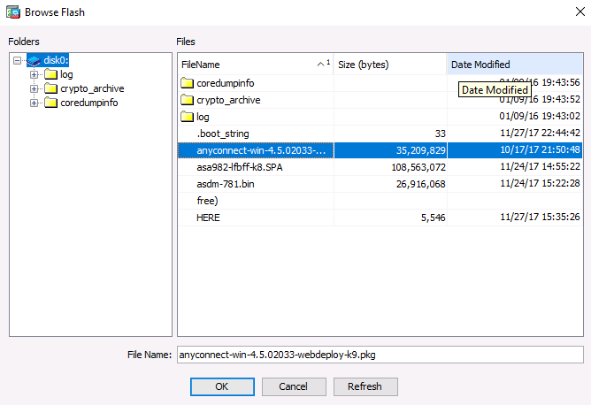

* + - 1. Click **OK** again to return to the Client Image window.

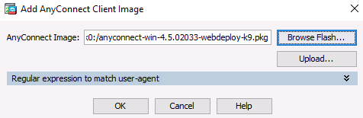

* + - 1. The selected image is now displayed on the Client Image window. Click **Next** to continue.

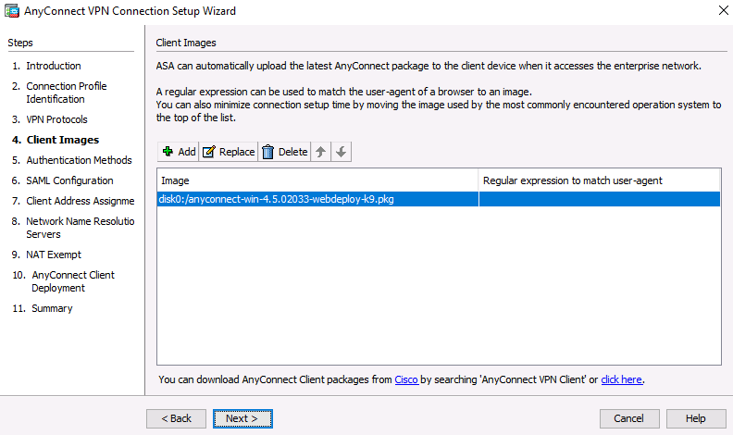

* + 1. Configure AAA local authentication.
       1. On the Authentication Methodsscreen, ensure that the AAA Server Group is specified as **LOCAL**.
       2. Enter a new user named **REMOTEuser** with the password **cisco12345**. Click **Add**.

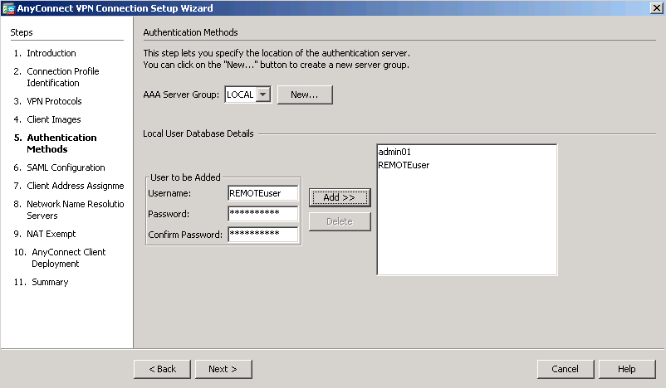

* + - 1. Click **Next** to continue.
    1. Configure the SAML Configuration.
       1. Leave the default settings for a SAML and the authentication method and click **Next**.

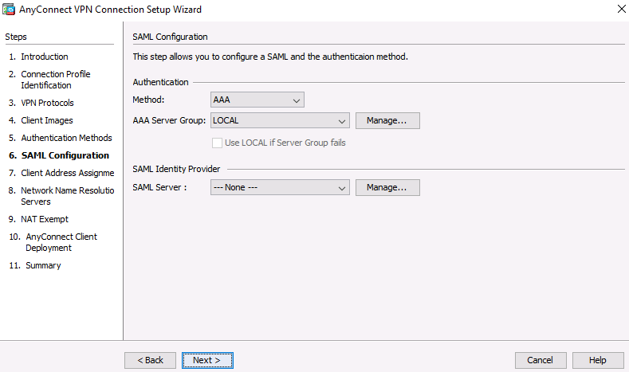

* + 1. Configure the client address assignment.
       1. In the Client Address Assignmentwindow, click **New** to create an IPv4 address pool.

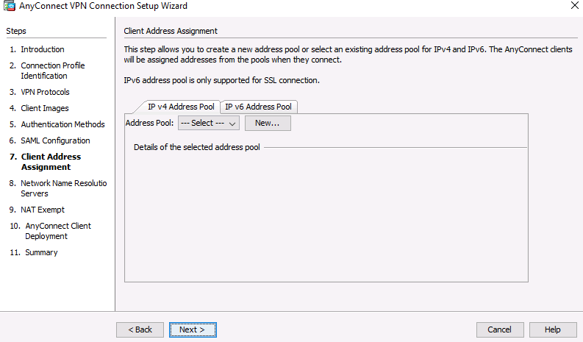

* + - 1. In the Add IPv4 Pool window, name the pool **Remote-Pool** with a starting IP address of **192.168.1.100**, an ending IP address of **192.168.1.125**, and a subnet mask of **255.255.255.0**. Click **OK** to return to the Client Address Assignment window, which now displays the newly created remote user IP address pool.

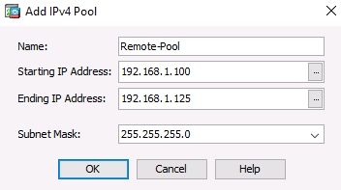

* + - 1. The Client Address Assignment window now displays the newly created remote user IP address pool. Click **Next** to continue.

. 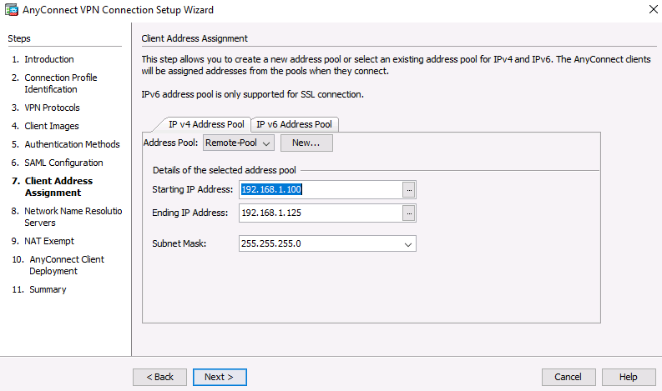

* + 1. Configure the network name resolution.

On the Network Name Resolution Servers screen, enter the IP address of a DNS server (**192.168.2.3**). Leave the current domain name as **ccnasecurity.com**. Click **Next** to continue.

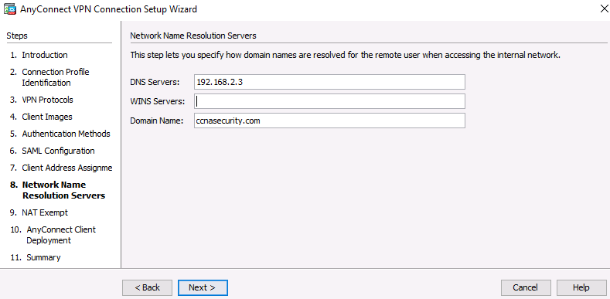

* + 1. Exempt address translation for VPN traffic.

On the NAT Exempt screen, click the **Exempt VPN traffic from network address translation** check box. Do not change the default entries for the Inside Interface (**inside**) and the Local Network (**any4**). Click **Next** to continue.

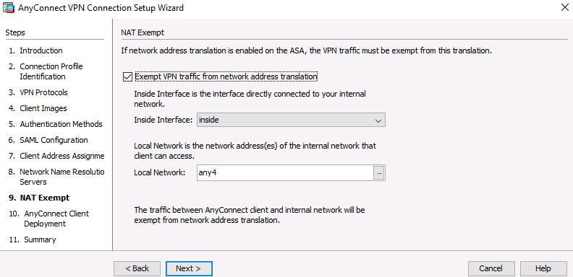

* + 1. Review the AnyConnect client deployment details.

On the AnyConnect Client Deploymentscreen, read the text describing the options, and then click **Next** to continue.

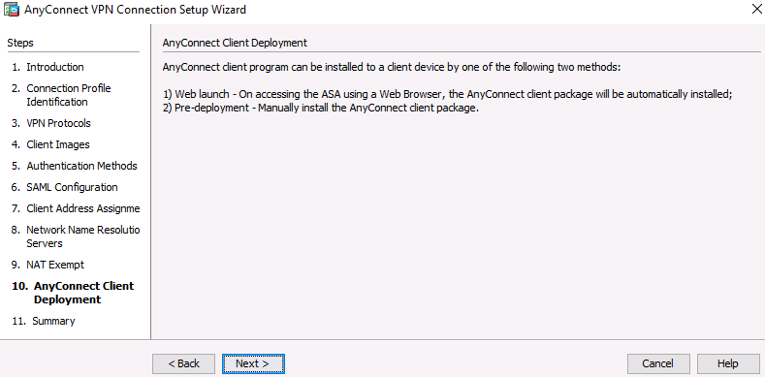

* + 1. Review the Summary screen and apply the configuration to the ASA.

On the Summary screen, review the configuration description and then click **Finish**.

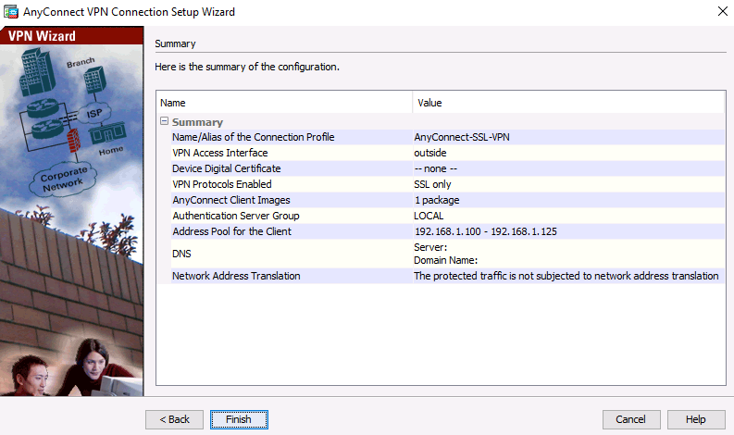

* + 1. Verify the AnyConnect client profile.

After the configuration is delivered to the ASA, the AnyConnect Connection Profiles screen displays.

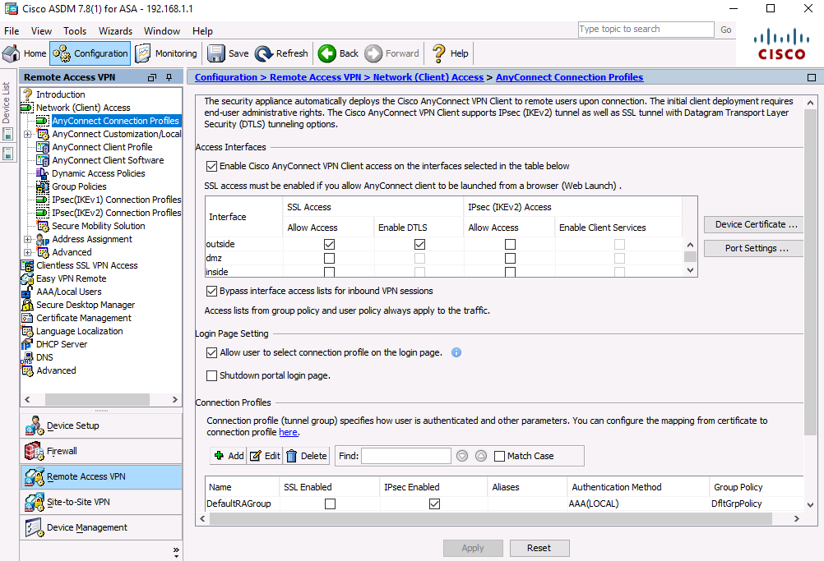

1. Connecting to an AnyConnect SSL VPN
   * 1. Log in from the remote host.
        1. Initially, you will establish a clientless SSL VPN connection to the ASA in order to download the AnyConnect client software. Open a web browser on PC-C. In the address field of the browser, enter **https://209.165.200.226** for the SSL VPN. SSL is required to connect to the ASA, therefore, use secure HTTP (HTTPS).

**Note**: If you encounter a prompt stating that the connection is not trusted or secure, accept the self-signed certificate to continue.

* + - 1. Enter the created username **REMOTEuser** with the password **cisco12345**. Click **Login** to continue.

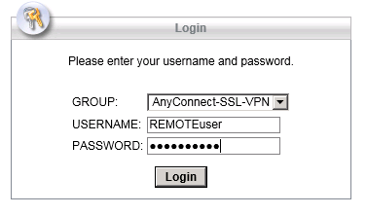

**Note**: The ASA may request confirmation that this is a trusted site. If requested, click **Yes** to proceed.

**Note:** If the AnyConnect client fails authentication, reset the password.

**Configuration > Remote Access VPN > Local Users > REMOTEuser > Edit > Identity > Change user password** (retype in the correct username and password combo).Click **OK** followed by clicking **Apply**.

* + 1. Perform platform detection (if required).

If the AnyConnect client must be downloaded, a security warning will display on the remote host. The ASA will detect whether ActiveX is available on the host system. In order for ActiveX to operate properly with the Cisco ASA, it is important that the security appliance is added as a trusted network site.

**Note**: If ActiveX is not detected, the AnyConnect client software must be manually downloaded and installed. Skip to **Step 3** for instructions on how to manually download the AnyConnect client software.

* + - 1. The ASA will begin a software auto-download process consisting of a series of compliance checks for the target system. The ASA performs the platform detection by querying the client system in an attempt to identify the type of client connecting to the security appliance. Based on the platform that is identified, the proper software package may be auto-downloaded.

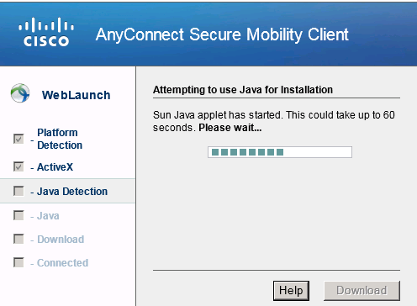

* + - 1. If you are presented with the AnyConnect Downloader window that indicates the 209.165.200.226 AnyConnect server could not be verified, click the **Change Setting** button.

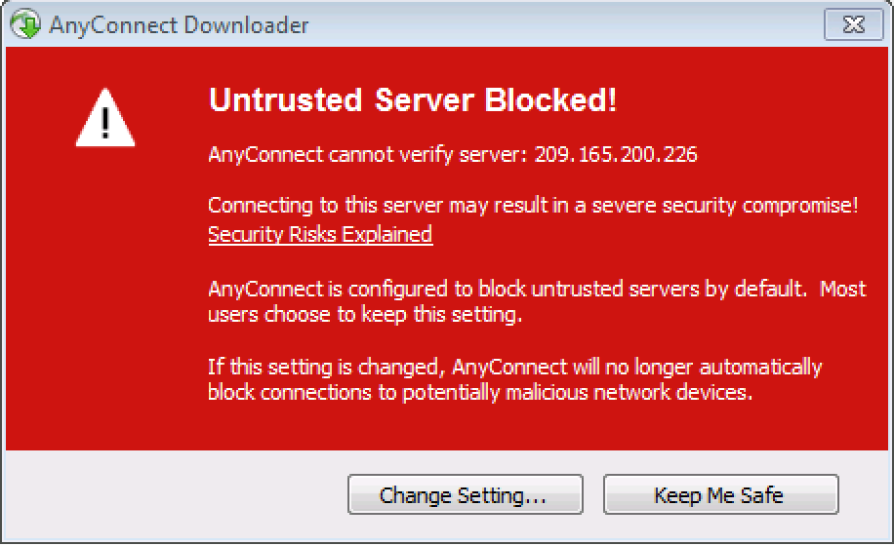

* + - 1. The AnyConnect Downloader will present a verification window to change the setting that blocks untrusted connections. Click **Apply Change**.

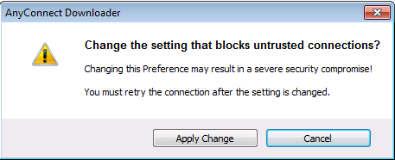

* + - 1. If you receive the Security Waning: Untrusted Server Certificate message, Click **Connect Anyway**.

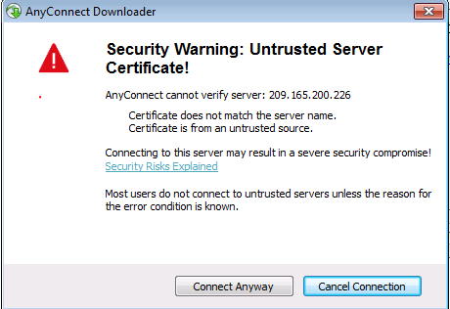

* + - 1. If you receive a message stating that Cisco AnyConnect will no longer block connections, then click on the **retry the connection** hyperlink to continue.

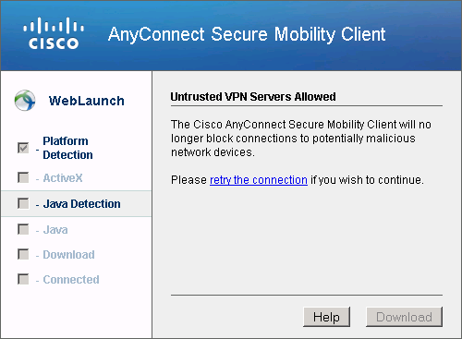

* + - 1. The AnyConnect Secure Mobility Client Downloader window counts down the download time.

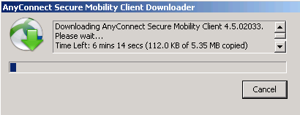

* + - 1. After the download is complete, the software will automatically start to install. Click **Yes** if asked to allow the program to make changes to the computer.

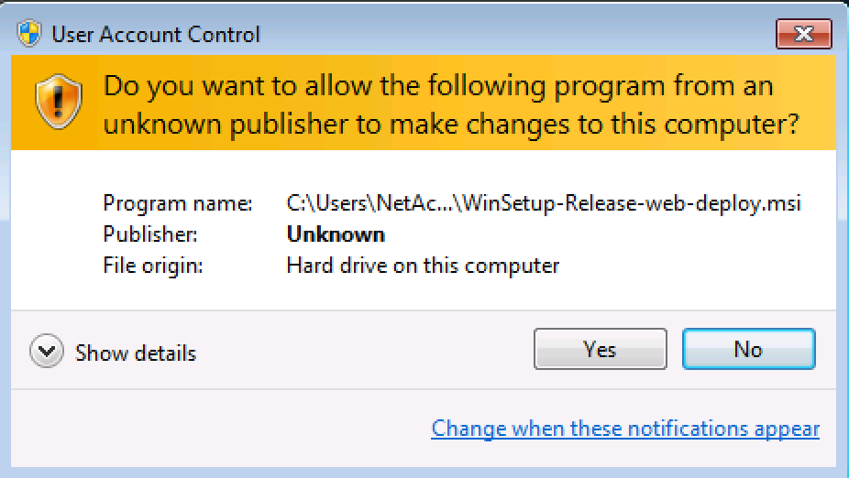

* + - 1. When installation is complete, the AnyConnect client will establish the SSL VPN connection.

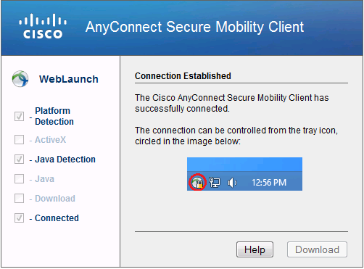

* + - 1. If the **Connected** option in the panel on the left is checked, skip to **Step 5**.   
         If the Connect option is not checked, continue to **Step 3**.
    1. Install the AnyConnect VPN Client (if required).

If ActiveX is not detected, the AnyConnect client software must be manually downloaded and installed.

* + - 1. On the Manual Installation screen, click **Download**.

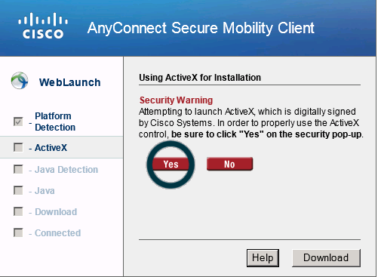

* + - 1. Click on the module **AnyConnect VPN**

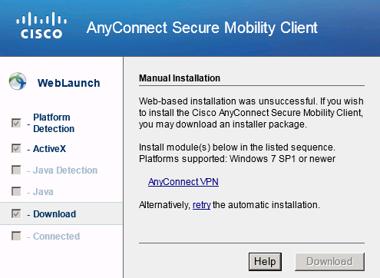

* + - 1. Click **Run** to install the AnyConnect VPN client.
      2. After the download is complete, the Cisco AnyConnect VPN Client Setup starts. Click **Next** to continue.

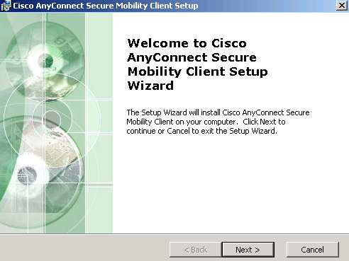

* + - 1. Read the End-User License Agreement. Select **I accept the terms in the License Agreement** and click **Next** to continue.

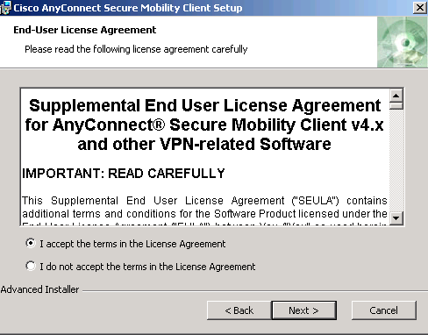

* + - 1. The Ready to Install window is displayed. Click **Install** to continue.

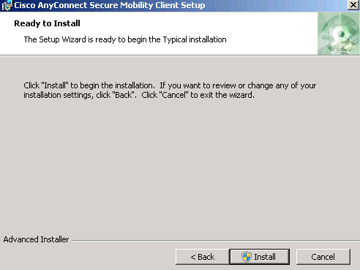

**Note**: If a security warning is displayed, click **Yes** to continue.

* + - 1. Click **Finish** to complete the installation.

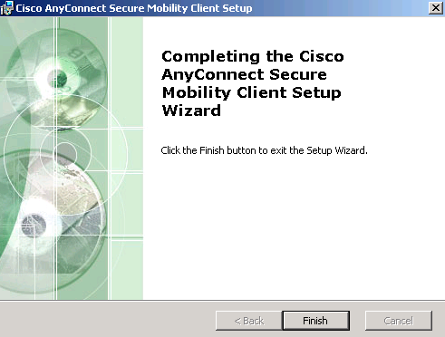

* + 1. Establish an AnyConnect SSL VPN Connection.
       1. When the AnyConnect VPN client has been installed, manually start the program by clicking **Start**, type **cisco any** and select **Cisco AnyConnect Secure Mobility Client** to launch the program.

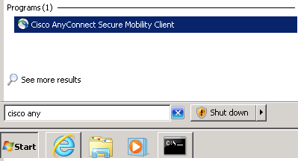

* + - 1. When prompted to enter the secure gateway address, enter **209.165.200.226** in the Connect to field, and click **Connect**.

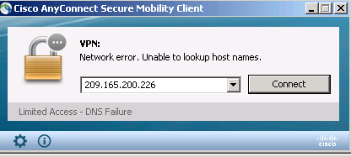

**Note**: If a security warning is displayed, click **Yes** to proceed.

* + - 1. If you are presented with the AnyConnect Secure Mobility Client window that indicates the 209.165.200.226 AnyConnect server could not be verified, click the **Change Setting** button. (Otherwise Proceed to Step **e.**)

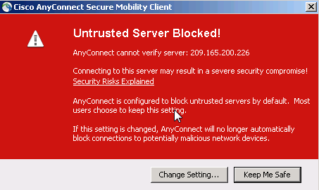

* + - 1. The AnyConnect Downloader will present a window. Remove the checkmark from “Block connections to untrusted servers”. Close the window and Connect to 209.165.200.226 again.

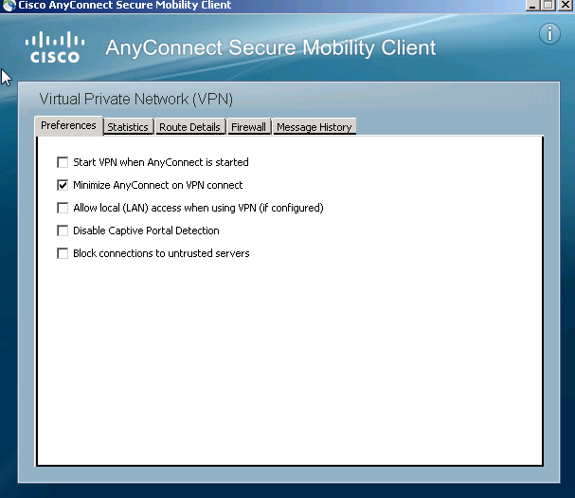

* + - 1. If you receive the Security Warning: Untrusted Server Certificate! Window, click **Connect Anyway**

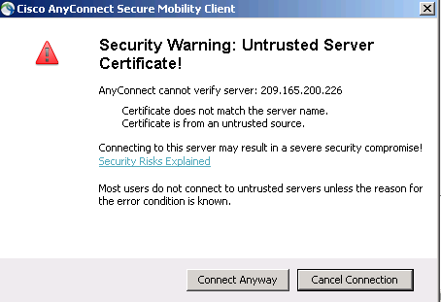

* + - 1. When prompted, enter **REMOTEuser** for the username and **cisco12345** as the password and click **OK.**

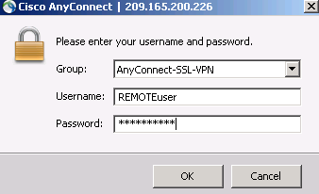

**NOTE**: If you receive a Login Failed message, go to PC-B ASDM **Monitoring** > **VPN** > **VPN** **Statistics** > **Sessions**.

Click the Filter By: dropdown and select “**All Remote Access**” and then click **Logout** for the current VPN sessions. And then try to connect from PC-C again.

* + 1. Confirm VPN connectivity.

When the full tunnel SSL VPN connection is established, an icon will appear in the system tray that signifies that the client has successfully connected to the SSL VPN network.



* + - 1. Display connection statistics and information by double-clicking the **AnyConnect** icon in the system tray. You can also disconnect the SSN VPN session from here.
      2. Click the **gear icon** at the bottom left corner of the Cisco AnyConnect Secure Mobility client window.

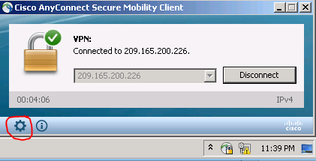

* + - 1. Use the scroll bar on the right side of the Virtual Private Network (VPN) – Statistics tab for additional connection information.

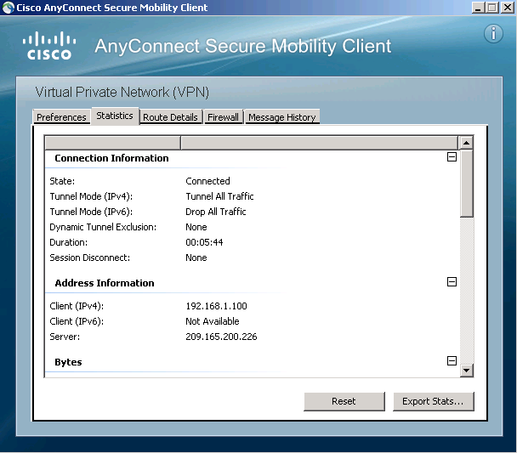

**Note:** The inside IP address that is assigned to the client from the VPN pool is 192.168.1.100-125.

* + - 1. From a command prompt on the remote host PC-C, verify the IP addressing by using the **ipconfig** command.   
         Notice that there are two IP addresses listed. One is for the PC-C remote host local IP address (172.16.3.3) and the other is the IP address assigned to the SSL VPN tunnel (192.168.1.100).

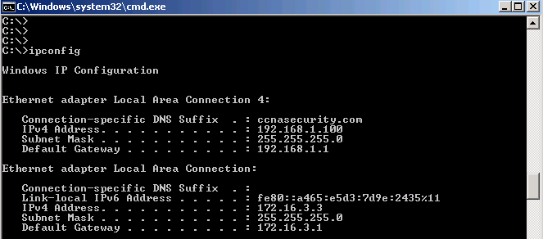

* + - 1. From remote host PC-C, ping PC-B (**192.168.1.3**) to verify connectivity.

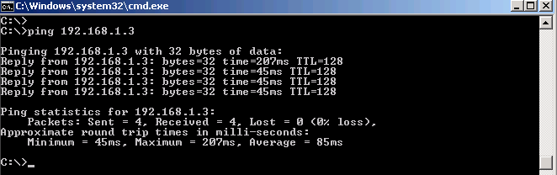

* + 1. Use the ASDM Monitor to view the AnyConnect remote user session.

**Note:** Future SSL VPN sessions can be launched through the web portal or through the installed Cisco AnyConnect SSL VPN client. While the remote user at PC-C is still logged in using the AnyConnect client, you can view the session statistics by using the ASDM monitor.

Return to the ASDM on PC-B. On the ASDM menu bar, click **Monitoring** and then select **VPN** > **VPN Statistics** > **Sessions**.

Click the **Filter By** pull-down list and select **AnyConnect Client**.   
You should see the **Remoteuser** session logged in from PC-C, which has been assigned an inside network IP address of 192.168.1.100 by the ASA.

**Note**: You may need to click **Refresh** to display the remote user session.

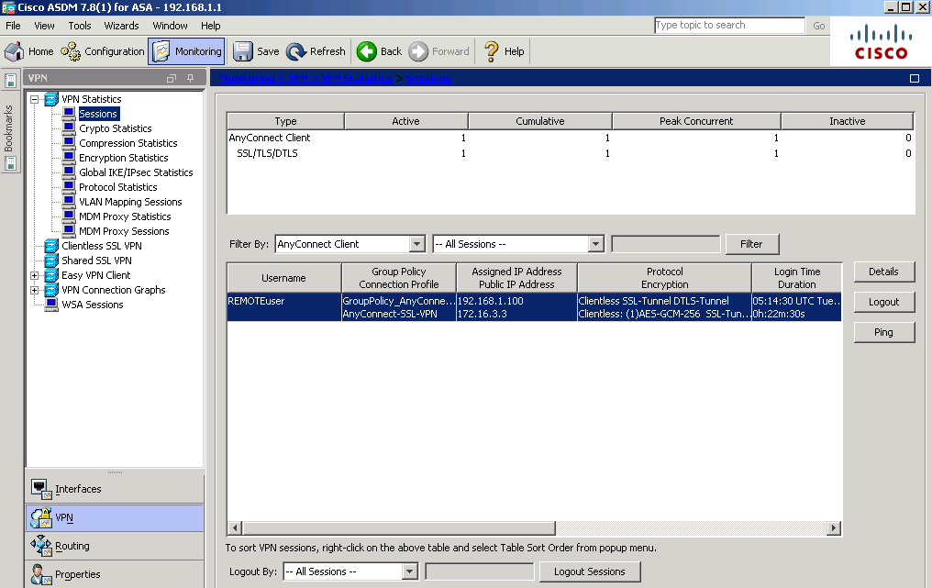

1. Reflection
   1. Describe at least two benefits of client–based vs. clientless VPNs?

_______________________________________________________________________________________

_______________________________________________________________________________________

_______________________________________________________________________________________

_______________________________________________________________________________________

_______________________________________________________________________________________

Users have access to the same internal network resources as if they were on the LAN. Client-based VPN solutions, such as AnyConnect, can be configured to automatically download the proper client software based on the client platform characteristics.

* 1. Describe at least one difference between using SSL compared to IPsec for remote access tunnel encryption?

_______________________________________________________________________________________

_______________________________________________________________________________________

_______________________________________________________________________________________

_______________________________________________________________________________________

Client-based VPNs can offer a more secure tunnel, if using IPsec, but are somewhat more complex to configure.

1. Router Interface Summary Table

|  |  |  |  |  |
| --- | --- | --- | --- | --- |
| Router Interface Summary | | | | |
| Router Model | Ethernet Interface #1 | Ethernet Interface #2 | Serial Interface #1 | Serial Interface #2 |
| 1800 | Fast Ethernet 0/0 (F0/0) | Fast Ethernet 0/1 (Fa0/1) | Serial 0/0/0 (S0/0/0) | Serial 0/0/1 (S0/0/1) |
| 1900 | Gigabit Ethernet 0/0 (G0/0) | Gigabit Ethernet 0/1 (G0/1) | Serial 0/0/0 (S0/0/0) | Serial 0/0/1 (S0/0/1) |
| 2801 | Fast Ethernet 0/0 (F0/0) | Fast Ethernet 0/1 (F0/1) | Serial 0/1/0 (S0/1/0) | Serial 0/1/1 (S0/1/1) |
| 2811 | Fast Ethernet 0/0 (F0/0) | Fast Ethernet 0/1 (F0/1) | Serial 0/0/0 (S0/0/0) | Serial 0/0/1 (S0/0/1) |
| 2900 | Gigabit Ethernet 0/0 (G0/0) | Gigabit Ethernet 0/1 (G0/1) | Serial 0/0/0 (S0/0/0) | Serial 0/0/1 (S0/0/1) |
| **Note**: To find out how the router is configured, look at the interfaces to identify the type of router and how many interfaces the router has. There is no way to effectively list all the combinations of configurations for each router class. This table includes identifiers for the possible combinations of Ethernet and Serial interfaces in the device. The table does not include any other type of interface, even though a specific router may contain one. An example of this might be an ISDN BRI interface. The string in parenthesis is the legal abbreviation that can be used in Cisco IOS commands to represent the interface. | | | | |

1. Device Configs
2. ASA 5506 Final Config

**CCNAS-ASA# show run**

: Saved

:

: Serial Number: JAD2002064E

: Hardware: ASA5506W, 4096 MB RAM, CPU Atom C2000 series 1250 MHz, 1 CPU (4 cores)

:

ASA Version 9.8(2)

!

hostname CCNAS-ASA

domain-name ccnasecurity.com

enable password $sha512$5000$u9efEcwrY9udDR9cFiCMFw==$yJ7TbZROmyVmo37ahp6vLQ== pbkdf2

xlate per-session deny tcp any4 any4

xlate per-session deny tcp any4 any6

xlate per-session deny tcp any6 any4

xlate per-session deny tcp any6 any6

xlate per-session deny udp any4 any4 eq domain

xlate per-session deny udp any4 any6 eq domain

xlate per-session deny udp any6 any4 eq domain

xlate per-session deny udp any6 any6 eq domain

names

ip local pool Remote-Pool 192.168.1.100-192.168.1.125 mask 255.255.255.0

!

interface GigabitEthernet1/1

nameif outside

security-level 0

ip address 209.165.200.226 255.255.255.248

!

interface GigabitEthernet1/2

nameif inside

security-level 100

ip address 192.168.1.1 255.255.255.0

!

interface GigabitEthernet1/3

nameif dmz

security-level 70

ip address 192.168.2.1 255.255.255.0

!

interface GigabitEthernet1/4

shutdown

no nameif

no security-level

no ip address

!

interface GigabitEthernet1/5

shutdown

no nameif

no security-level

no ip address

!

interface GigabitEthernet1/6

shutdown

no nameif

no security-level

no ip address

!

interface GigabitEthernet1/7

shutdown

no nameif

no security-level

no ip address

!

interface GigabitEthernet1/8

shutdown

no nameif

no security-level

no ip address

!

interface Management1/1

management-only

shutdown

no nameif

no security-level

no ip address

!

ftp mode passive

dns server-group DefaultDNS

domain-name ccnasecurity.com

object network inside-net

subnet 192.168.1.0 255.255.255.0

object network dmz-server

host 192.168.2.3

object network NETWORK_OBJ_192.168.1.96_27

subnet 192.168.1.96 255.255.255.224

access-list OUTSIDE-DMZ extended permit ip any host 192.168.2.3

pager lines 24

mtu outside 1500

mtu inside 1500

mtu dmz 1500

icmp unreachable rate-limit 1 burst-size 1

no asdm history enable

arp timeout 14400

no arp permit-nonconnected

arp rate-limit 16384

nat (inside,outside) source static any any destination static NETWORK_OBJ_192.168.1.96_27 NETWORK_OBJ_192.168.1.96_27 no-proxy-arp route-lookup

!

object network inside-net

nat (inside,outside) dynamic interface

object network dmz-server

nat (dmz,outside) static 209.165.200.227

access-group OUTSIDE-DMZ in interface outside

route outside 0.0.0.0 0.0.0.0 209.165.200.225 1

timeout xlate 3:00:00

timeout pat-xlate 0:00:30

timeout conn 1:00:00 half-closed 0:10:00 udp 0:02:00 sctp 0:02:00 icmp 0:00:02

timeout sunrpc 0:10:00 h323 0:05:00 h225 1:00:00 mgcp 0:05:00 mgcp-pat 0:05:00

timeout sip 0:30:00 sip_media 0:02:00 sip-invite 0:03:00 sip-disconnect 0:02:00

timeout sip-provisional-media 0:02:00 uauth 0:05:00 absolute

timeout tcp-proxy-reassembly 0:01:00

timeout floating-conn 0:00:00

timeout conn-holddown 0:00:15

timeout igp stale-route 0:01:10

user-identity default-domain LOCAL

aaa authentication telnet console LOCAL

aaa authentication ssh console LOCAL

aaa authentication http console LOCAL

aaa authentication login-history

http server enable

http 192.168.1.0 255.255.255.0 inside

no snmp-server location

no snmp-server contact

service sw-reset-button

crypto ipsec security-association pmtu-aging infinite

crypto ca trustpool policy

telnet 192.168.1.0 255.255.255.0 inside

telnet timeout 10

ssh stricthostkeycheck

ssh 192.168.1.0 255.255.255.0 inside

ssh timeout 10

ssh key-exchange group dh-group1-sha1

console timeout 0

threat-detection basic-threat

threat-detection statistics access-list

no threat-detection statistics tcp-intercept

webvpn

enable outside

anyconnect image disk0:/anyconnect-win-4.5.02033-webdeploy-k9.pkg 1

anyconnect enable

tunnel-group-list enable

cache

disable

error-recovery disable

group-policy GroupPolicy_AnyConnect-SSL-VPN internal

group-policy GroupPolicy_AnyConnect-SSL-VPN attributes

wins-server none

dns-server value 192.168.2.3

vpn-tunnel-protocol ssl-client

default-domain value ccnasecurity.com

dynamic-access-policy-record DfltAccessPolicy

username admin01 password $sha512$5000$DQXP07KnlaJ2jEEO4YbdZg==$L0US/ovC0GnsFwGBW8UEMw== pbkdf2

username REMOTEuser password $sha512$5000$PoXUW9+tKxziomYveVWyzQ==$hppsPRtQrkjY4KShlHcQig== pbkdf2

tunnel-group AnyConnect-SSL-VPN type remote-access

tunnel-group AnyConnect-SSL-VPN general-attributes

address-pool Remote-Pool

default-group-policy GroupPolicy_AnyConnect-SSL-VPN

tunnel-group AnyConnect-SSL-VPN webvpn-attributes

group-alias AnyConnect-SSL-VPN enable

!

class-map inspection_default

match default-inspection-traffic

!

policy-map type inspect dns preset_dns_map

parameters

message-length maximum client auto

message-length maximum 512

no tcp-inspection

policy-map global_policy

class inspection_default

inspect ftp

inspect h323 h225

inspect h323 ras

inspect ip-options

inspect netbios

inspect rsh

inspect rtsp

inspect skinny

inspect esmtp

inspect sqlnet

inspect sunrpc

inspect tftp

inspect sip

inspect xdmcp

inspect dns preset_dns_map

inspect icmp

policy-map type inspect dns migrated_dns_map_2

parameters

message-length maximum client auto

message-length maximum 512

no tcp-inspection

policy-map type inspect dns migrated_dns_map_1

parameters

message-length maximum client auto

message-length maximum 512

no tcp-inspection

!

service-policy global_policy global

prompt hostname context

no call-home reporting anonymous

call-home

profile CiscoTAC-1

no active

destination address http https://tools.cisco.com/its/service/oddce/services/DDCEService

destination address email callhome@cisco.com

destination transport-method http

subscribe-to-alert-group diagnostic

subscribe-to-alert-group environment

subscribe-to-alert-group inventory periodic monthly

subscribe-to-alert-group configuration periodic monthly

subscribe-to-alert-group telemetry periodic daily

Cryptochecksum:ff321c384571da0f5753f532ab0e8c1d

: end

1. Router R1

R1#show run

Building configuration...

Current configuration : 2116 bytes

!

! Last configuration change at 21:45:14 UTC Tue Jan 6 2015

!

version 15.4

service timestamps debug datetime msec

service timestamps log datetime msec

no service password-encryption

!

hostname R1

!

boot-start-marker

boot-end-marker

!

!

security passwords min-length 10

enable secret 9 $9$/eV07rwi1/c5nU$F8WEVW3ctUXbKpISW69AMqLXFwze0zkG8lSsBbFivnQ

!

no aaa new-model

memory-size iomem 15

!

ip domain name ccnasecurity.com

ip cef

no ipv6 cef

!

multilink bundle-name authenticated

!

cts logging verbose

!

voice-card 0

!

license udi pid CISCO2911/K9 sn FTX1713ALKC

license accept end user agreement

license boot module c2900 technology-package securityk9

license boot module c2900 technology-package uck9

license boot module c2900 technology-package datak9

!

username admin01 secret 9 $9$0rPUTv6Jsqpm8E$5xhkGpHlVhkVfn2Jjj/tjskduz884Z2h/im7DO/vLAI

!

redundancy

!

interface Embedded-Service-Engine0/0

no ip address

shutdown

!

interface GigabitEthernet0/0

ip address 209.165.200.225 255.255.255.248

duplex auto

speed auto

!

interface GigabitEthernet0/1

no ip address

shutdown

duplex auto

speed auto

!

interface GigabitEthernet0/2

no ip address

shutdown

duplex auto

speed auto

!

interface Serial0/0/0

ip address 10.1.1.1 255.255.255.252

clock rate 125000

!

interface Serial0/0/1

no ip address

shutdown

!

!

ip forward-protocol nd

!

no ip http server

no ip http secure-server

!

ip route 0.0.0.0 0.0.0.0 Serial0/0/0

!

control-plane

!

mgcp behavior rsip-range tgcp-only

mgcp behavior comedia-role none

mgcp behavior comedia-check-media-src disable

mgcp behavior comedia-sdp-force disable

!

mgcp profile default

!

gatekeeper

shutdown

!

line con 0

exec-timeout 5 0

logging synchronous

login local

line aux 0

line 2

no activation-character

no exec

transport preferred none

transport output lat pad telnet rlogin lapb-ta mop udptn v120 ssh

stopbits 1

line vty 0 4

exec-timeout 5 0

logging synchronous

login local

transport input ssh

!

scheduler allocate 20000 1000

!

end

1. Router R2

R2#show run

Building configuration...

Current configuration : 2138 bytes

!

! Last configuration change at 17:46:15 UTC Thu Nov 30 2017

!

version 15.4

service timestamps debug datetime msec

service timestamps log datetime msec

no service password-encryption

!

hostname R2

!

boot-start-marker

boot-end-marker

!

security passwords min-length 10

enable secret 9 $9$pSU.VqT1eITgEk$pcZH4GnX.tf/hoK13BS3ARXpaksGSIj4kPGJETt..e6

!

no aaa new-model

memory-size iomem 15

!

ip domain name ccnasecurity.com

ip cef

no ipv6 cef

!

multilink bundle-name authenticated

!

cts logging verbose

!

voice-card 0

!

license udi pid CISCO2911/K9 sn FTX1713ALJP

license boot module c2900 technology-package securityk9

license boot module c2900 technology-package uck9

license boot module c2900 technology-package datak9

!

username admin01 secret 9 $9$/90PblQXcF.cjE$CK90fDk12SSHj2NB4MxRSKXxoV2ly/bGCt2pzZLVnvU

!

redundancy

!

interface Embedded-Service-Engine0/0

no ip address

shutdown

!

interface GigabitEthernet0/0

no ip address

shutdown

duplex auto

speed auto

!

interface GigabitEthernet0/1

no ip address

shutdown

duplex auto

speed auto

!

interface GigabitEthernet0/2

no ip address

shutdown

duplex auto

speed auto

!

interface Serial0/0/0

ip address 10.1.1.2 255.255.255.252

!

interface Serial0/0/1

ip address 10.2.2.2 255.255.255.252

clock rate 125000

!

ip forward-protocol nd

!

no ip http server

no ip http secure-server

!

ip route 172.16.3.0 255.255.255.0 Serial0/0/1

ip route 209.165.200.224 255.255.255.248 Serial0/0/0

!

control-plane

!

mgcp behavior rsip-range tgcp-only

mgcp behavior comedia-role none

mgcp behavior comedia-check-media-src disable

mgcp behavior comedia-sdp-force disable

!

mgcp profile default

!

gatekeeper

shutdown

!

line con 0

exec-timeout 5 0

logging synchronous

login local

line aux 0

line 2

no activation-character

no exec

transport preferred none

transport output lat pad telnet rlogin lapb-ta mop udptn v120 ssh

stopbits 1

line vty 0 4

exec-timeout 5 0

logging synchronous

login local

transport input ssh

!

scheduler allocate 20000 1000

!

end

1. Router R3

R3#show run

Building configuration...

Current configuration : 2148 bytes

!

! Last configuration change at 21:44:22 UTC Tue Jan 6 2015

!

version 15.4

service timestamps debug datetime msec

service timestamps log datetime msec

no service password-encryption

!

hostname R3

!

boot-start-marker

boot-end-marker

!

security passwords min-length 10

enable secret 9 $9$FQJ4YhC61ejiTE$wd5HWvaYisAw8qTMFPv8FVu5lpmLfyMQbGaRQIa58fM

!

no aaa new-model

memory-size iomem 15

!

ip domain name ccnasecurity.com

ip cef

no ipv6 cef

!

multilink bundle-name authenticated

!

cts logging verbose

!

voice-card 0

!

license udi pid CISCO2911/K9 sn FTX1713ALJV

license accept end user agreement

license boot module c2900 technology-package securityk9

license boot module c2900 technology-package uck9

license boot module c2900 technology-package datak9

!

vtp domain TSHOOT

vtp mode transparent

username admin01 secret 9 $9$vr3RrGdWIYu9JU$i7gxexUCKNGxxwRepvXf.QbofoDabbprKHtRlDR.IRU

!

redundancy

!

interface Embedded-Service-Engine0/0

no ip address

shutdown

!

interface GigabitEthernet0/0

no ip address

shutdown

duplex auto

speed auto

!

interface GigabitEthernet0/1

ip address 172.16.3.1 255.255.255.0

duplex auto

speed auto

!

interface GigabitEthernet0/2

no ip address

shutdown

duplex auto

speed auto

!

interface Serial0/0/0

no ip address

shutdown

clock rate 125000

!

interface Serial0/0/1

ip address 10.2.2.1 255.255.255.252

!

ip forward-protocol nd

!

no ip http server

no ip http secure-server

!

ip route 0.0.0.0 0.0.0.0 Serial0/0/1

!

control-plane

!

mgcp behavior rsip-range tgcp-only

mgcp behavior comedia-role none

mgcp behavior comedia-check-media-src disable

mgcp behavior comedia-sdp-force disable

!

mgcp profile default

!

gatekeeper

shutdown

!

line con 0

exec-timeout 5 0

logging synchronous

login local

line aux 0

line 2

no activation-character

no exec

transport preferred none

transport output lat pad telnet rlogin lapb-ta mop udptn v120 ssh

stopbits 1

line vty 0 4

exec-timeout 5 0

logging synchronous

login local

transport input ssh

!

scheduler allocate 20000 1000

!

end

1. Switches S1, S2 and S3 – Use default configs, except for host name